 | EUNOIA JUNIOR COLLEGE  JC2 Preliminary Examination 2024  General Certificate of Education Advanced Level  Higher 2
H2 GEOGRAPHY  Paper 1  INSERT |  | 9173/01  11 September 2024  3 Hours
READ THESE INSTRUCTIONS FIRST

The Insert contains all the Resources referred to in the questions.

This document consists of 9 printed pages and 3 blank pages.
[Turn over
2

Resource 1 for Question 1

Map depicting the Nile River Basin, its riparian states and the location of the Grand Ethiopian Renaissance Dam (GERD) along the Blue Nile

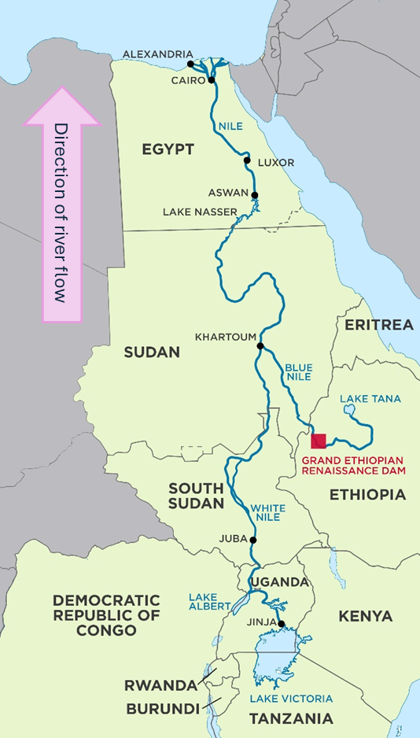

3

Resource 2 for Question 1

Estimated changes in annual water flow from the Blue Nile and Nile River before and after the construction of the GERD

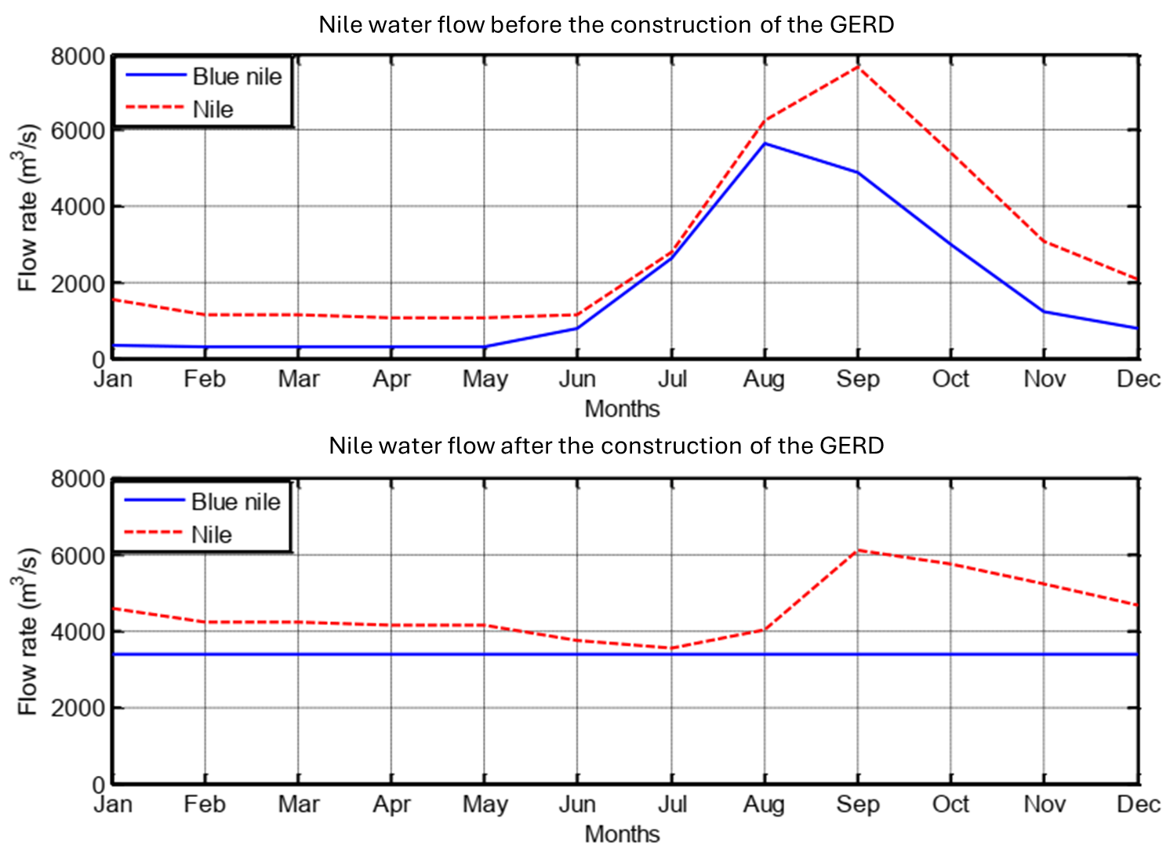

[Turn over

4

Resource 3 for Question 1

Satellite photographs of Grand Ethiopia Renaissance Dam (GERD) and its immediate vicinity in 2020 and 2023

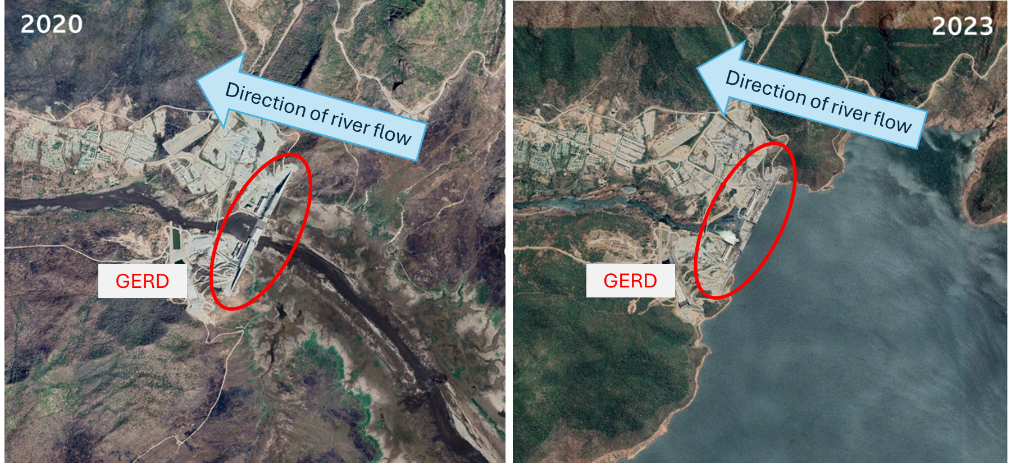

5

Resource 4A for Question 1

Ethiopia’s power needs

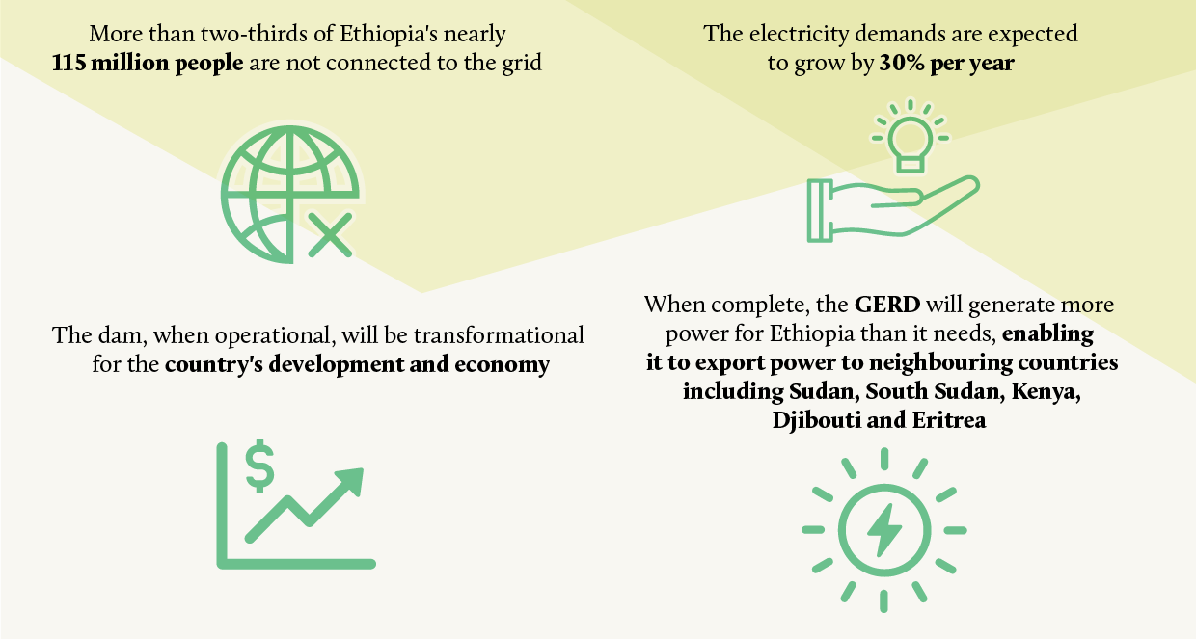

Resource 4B for Question 1

Egypt’s water needs

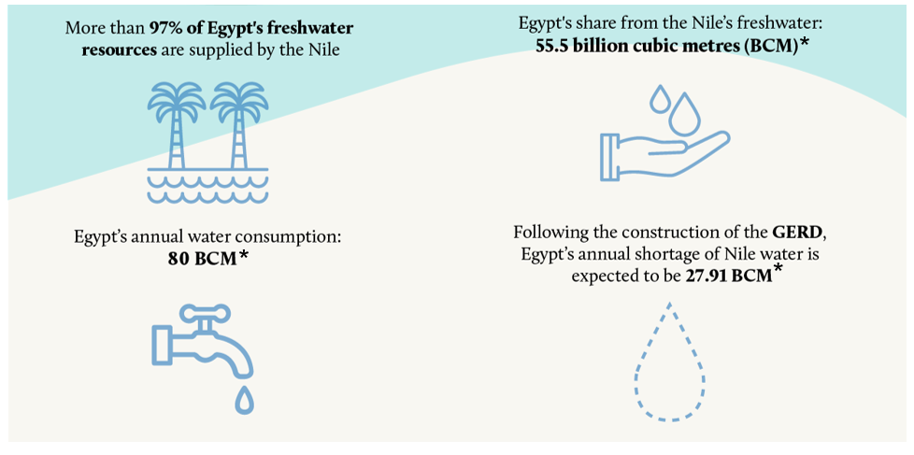
*BCM = billion cubic meters

[Turn over

6

Resource 5 for Question 1

Changes in solar installations in India from 2009 to 2019

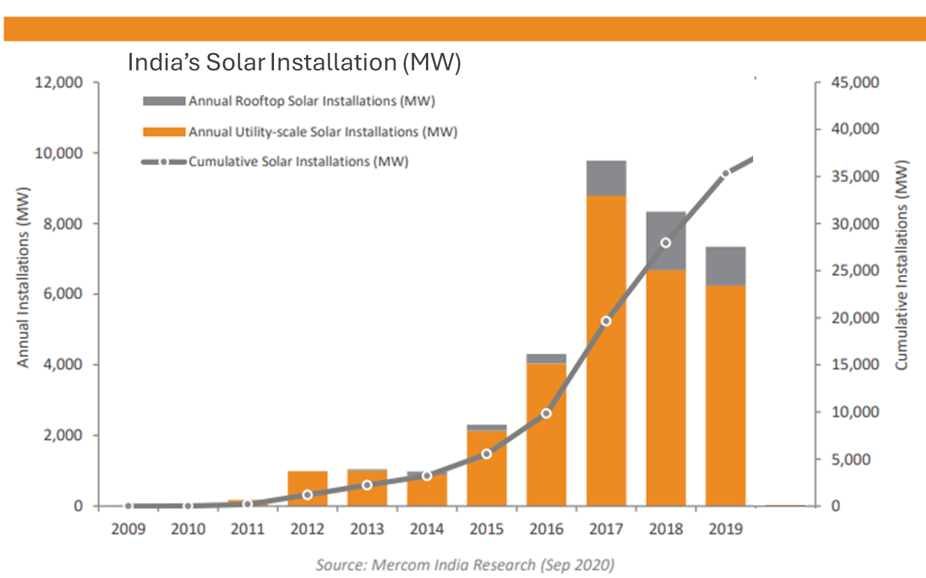

7

Resource 6A for Question 2

Climograph of Mumbai, India

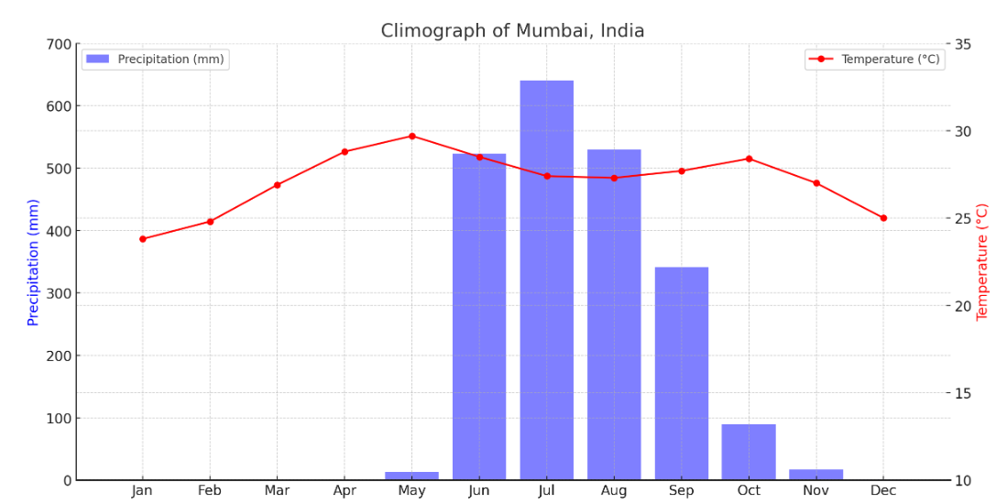

Resource 6B for Question 2

Climograph of Cairo, Egypt

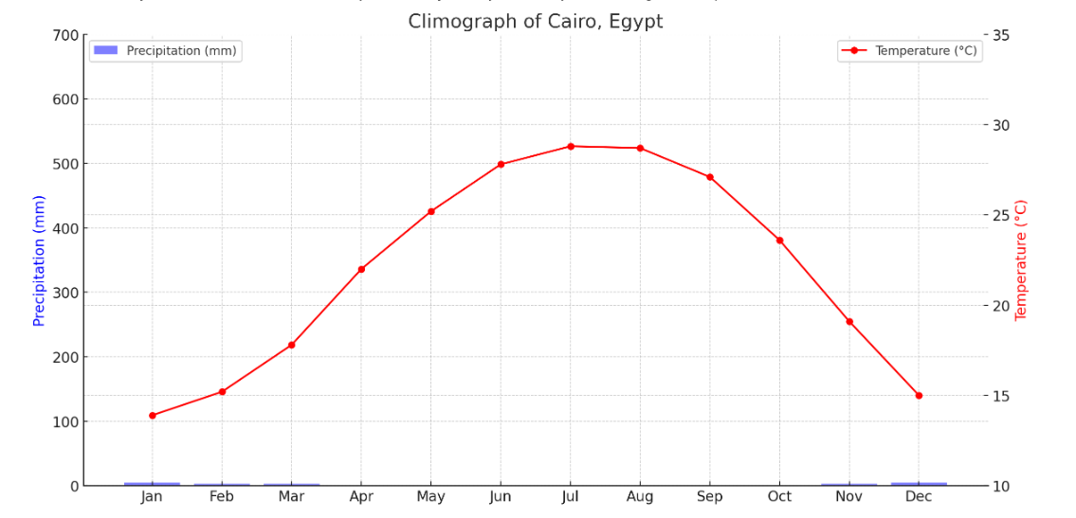

[Turn over
8

Resource 7 for Question 2

Regional wind system over India in June (left) and January (right)

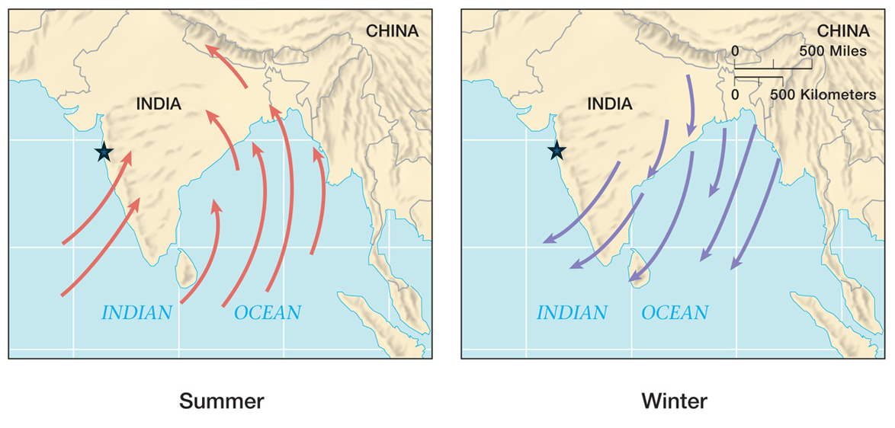
- Location of Mumbai in India.

Resource 8 for Question 2

Hydrograph of a drainage basin

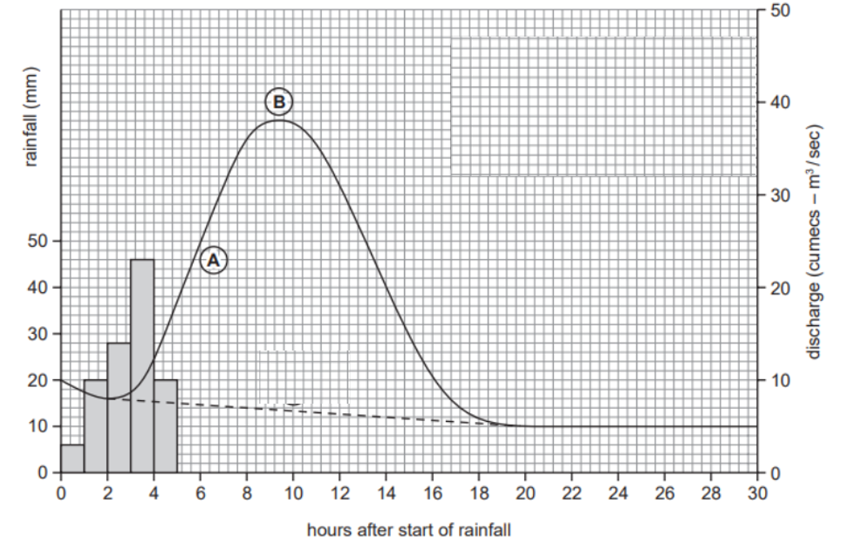

9

Resource 9 for Question 2

Fluvial landform found along the Brahmaputra River in India

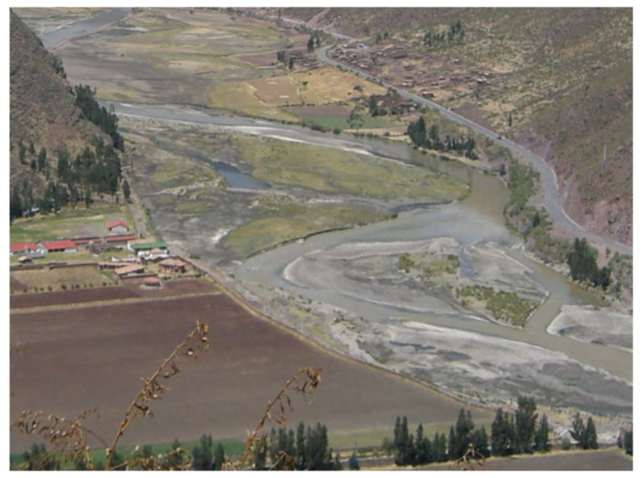

10

BLANK PAGE

11

BLANK PAGE

12

BLANK PAGE

